Image | 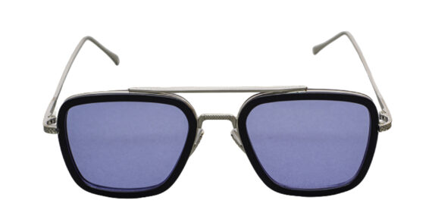
Brand | TOM FORD
Model Name | Hoch PSG
Price | RS 1500
PRODUCT DETAILS

